CITY OF CAPITOLA

CITY COUNCIL

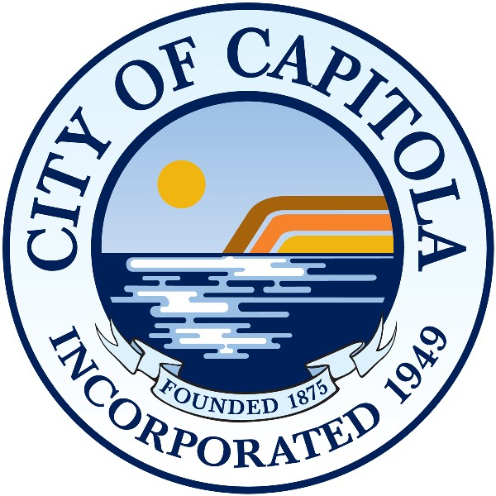

NOTICE OF CANCELLATION

NOTICE IS HEREBY GIVEN that
the Capitola Planning Commission meeting scheduled for Thursday,
November 7, 2024, at 6 p.m.
has been cancelled.
The next meeting will be on December 5, 2024, in the City Hall Council Chambers,
420 Capitola Avenue, Capitola, CA.

POSTED: __Rosie Wyatt_____
Rosie Wyatt, Acting Deputy City Clerk

